## Indian Unicorn Companies

**Dataset link -** <https://www.kaggle.com/datasets/foziashareen/indian-unicorn>

**Dashboard Link –** [Indian Unicorn Companies Dashboard | Tableau Public](https://public.tableau.com/app/profile/ashish.anand4858/viz/IndianUnicornCompaniesDashboard/Dashboard1?publish=yes)

**Visual 1 -** Sectors and Companies by Valuation ($B)

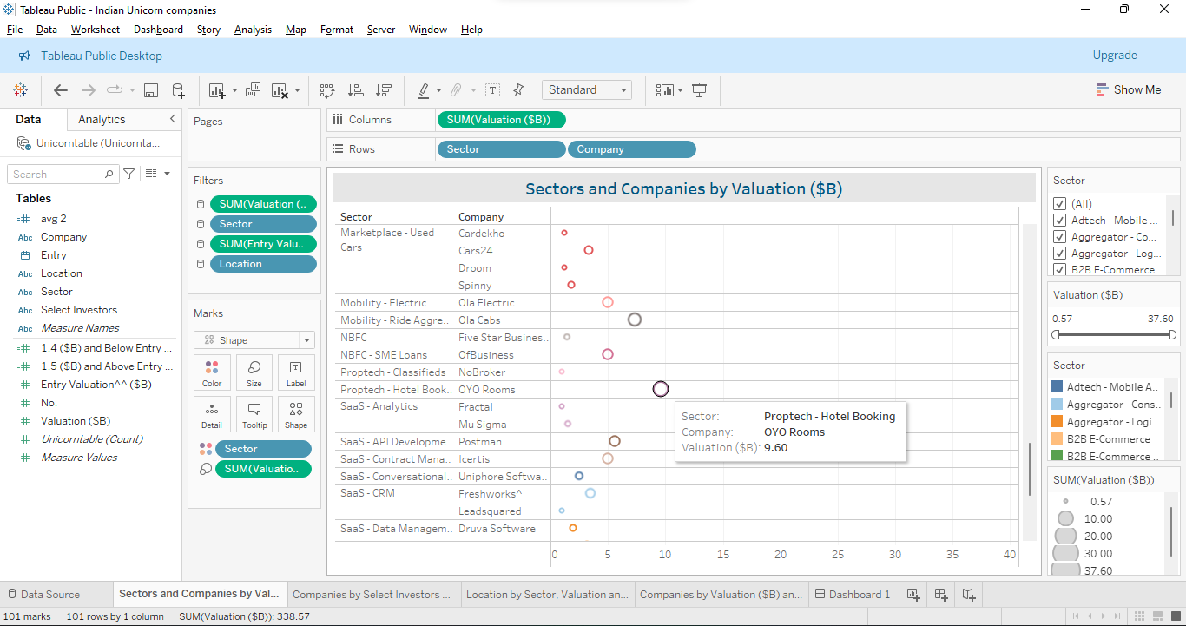

**Visual 2 -** Companies by Select Investors and Entry Valuation ($B)

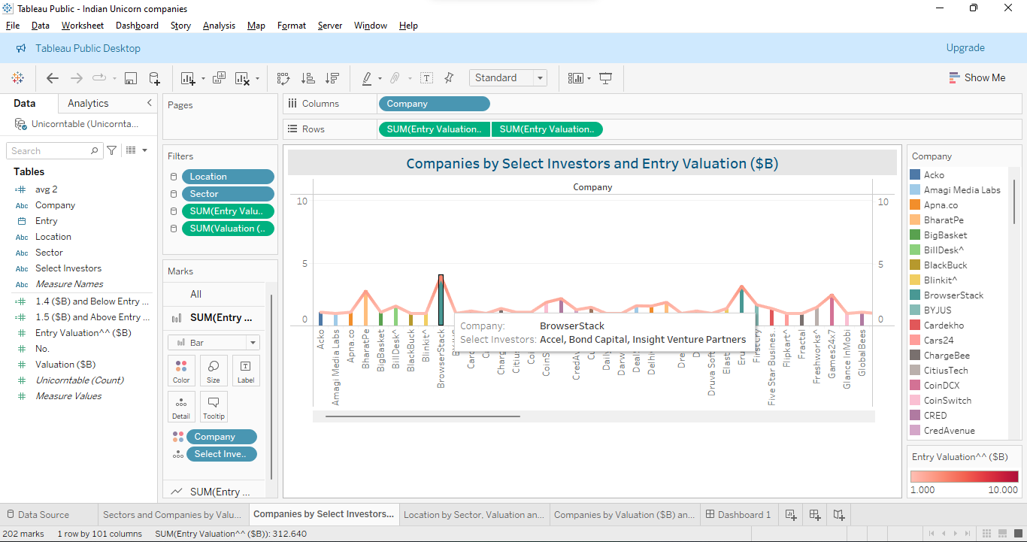

**Visual 3 -** Location by Sector, Valuation and Select Investors

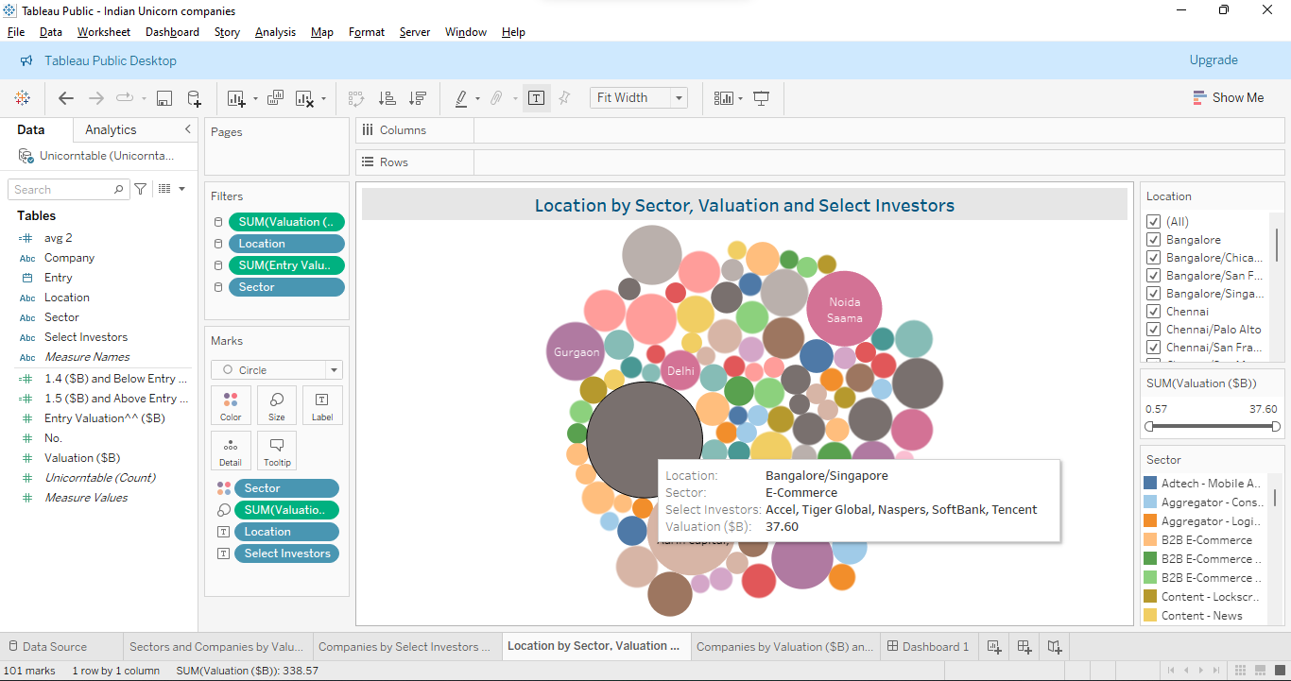

**Visual 4 -** Companies by Valuation ($B) and Entry Valuation ($B)

